On the round you will have to complete exactly the same level, but with using PROGRAMMING! We are pleased to introduce you “while” loops! You will need a condition for it and code that comes inside.

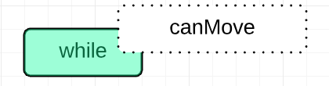

This is the way it should look:

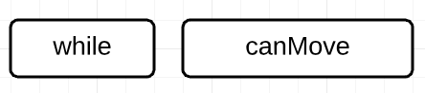

“canMove” is the condition. The loop will run until the condition is false.

To add blocks within the loop, divide it into two parts: left and right – the proportions will be 50% for each. If you place the next block to closer to the right part of the loop, it will be added inside:

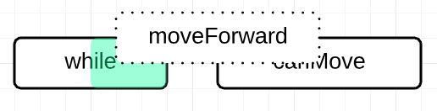

Inside the loop, which is shown by slightly moved to the right block:

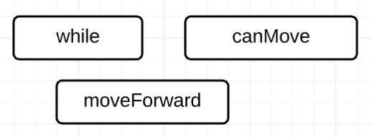

Otherwise, the new block will be separate from the loop:

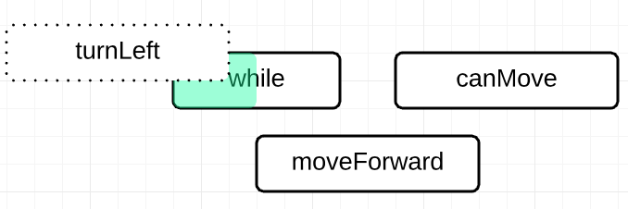

This has function “moveForward” inside the loop and “turnLeft” outside:

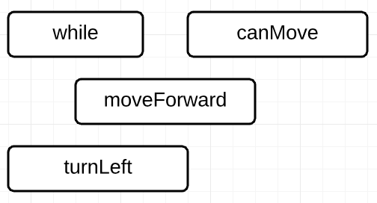

You can insert loops and statements inside other loops and statement in exact the same way. Try out it! See what happens!

P.S. See more in our tutorials for Level 1.